**CONTEXT DIAGRAM FOR RT OFFICE AUTOMATION SYSTEM**

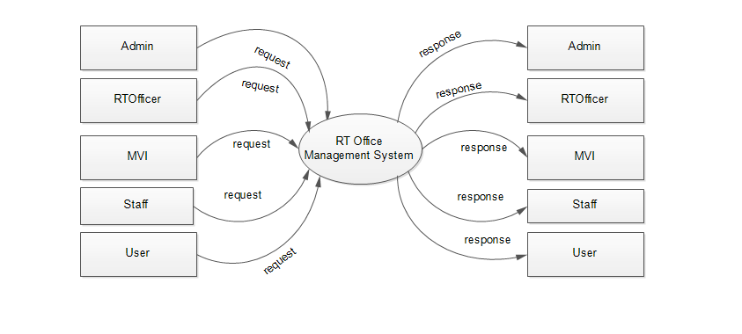

**ADMIN LEVEL 1 DFD FOR RT OFFICE AUTOMATION SYSTEM**

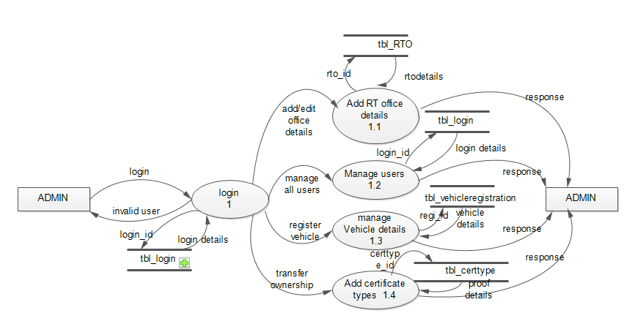

**USER LEVEL 1 DFD FOR RT OFFICE AUTOMATION SYSTEM**

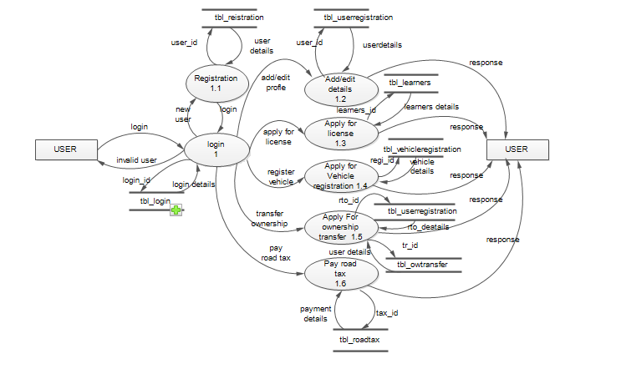

**STAFF LEVEL 1 DFD FOR RT OFFICE AUTOMATION SYSTEM**

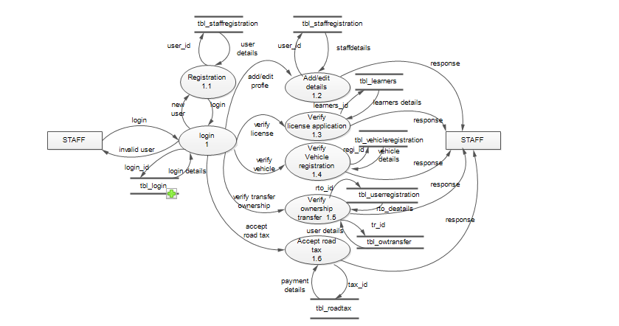

**MVI LEVEL 1 DFD FOR RT OFFICE AUTOMATION SYSTEM**

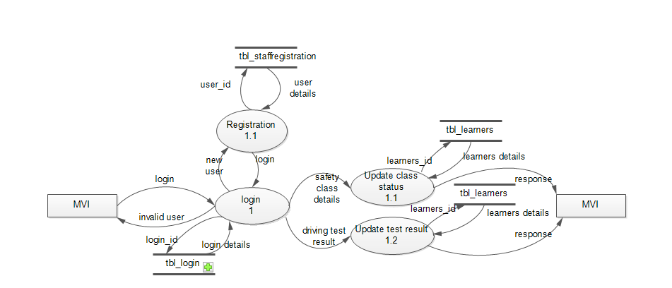

**RT OFFICER LEVEL 1 DFD FOR RT OFFICE AUTOMATION SYSTEM**

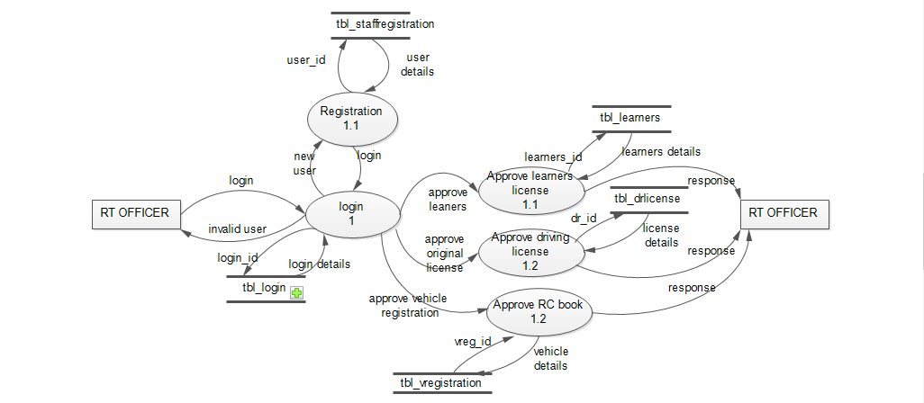

**LEVEL 2 DFD FOR MANAGE USER -ADMIN**

